Laboratory commands 1:

# Command line interface

**User EXEC mode:** >

**Privileged EXEC mode:** >enable

# …

**Global configuration mode:** #configure terminal

(config)# …

# Show command

use these commands in Privileged EXEC mode:

* **Show protocols:** Layer 3 protocols configured at router level and interface level
* **show ip route:** The actual route configured in the router
* **show running-configuration:** running configuration file

# Interface configuration

For non serial interfaces do not use clock commands, also for the serial interface without clock icon.

Router(config)# **interface Se0/0**

Router(config-if)# **ip address <A.B.C.D.> <netmask>**

Router(config-if)# **clock rate 64000**

Router(config-if)# **no shutdown**

# Static route configuration

For configure a static route: S (default AD:1)

Router(config)# **ip route Dest_IP_Add SubNet_Mask Next_Hop_Router AD**

**Example:** ip route 192.168.0.0 255.0.0.0 174.10.0.1

For configure the default route: S*

Router(config)# **ip route 0.0.0.0 0.0.0.0 Next_Hop_Router**

# 

# Rip protocol

For RIP v1: R => AD:120

Router(config)# **router rip**

Router(config-router)# **network 192.168.4.0**

Router(config-router)# **network 192.168.5.1**

Router(config-router)# **passive-interface Fa0/0 (if network is closed and don’t want to send rip ms)**

router# **show running-config**

**!**

**router rip**

**network 192.168.4.0**

**network 192.168.5.0 (auto correction)**

**!**

For RIP v2:

Router(config)# **router rip**

Router(config-router)# **version 2 (enable subnet mask field, for variable mask length networks)**

Router(config-router)# **no auto-summary (*in case of variable or discontinuous subnetting)***

# Default router distribution

For redistribute default route use this command, typically in a border router: (OSPF or RIP router-config)

Router(config)# **ip route 0.0.0.0 0.0.0.0 Next_Hop_Router_For_Internet**

Router(config-router)# **default-information originate**

For redistribute static route use this command:

Router(config)# **ip route Dest_IP_Add SubNet_Mask Next_Hop_Router**

Router(config-router)# **redistribute static**

# OSPF protocol

For OSPF: O => AD:110

Router(config)# **router ospf 1 (1 is the ID, any other number is okay)**

Router(config-router)# **network A.B.C.D. wildcard-mask area 0**

Router(config-router)# **passive-interface Fa0/0 (if network is closed and don’t want to send ospf)**

- **wildcard-mask:** obtained from netmask inverting 0s and 1s. 255.255.255.252 => 0.0.0.3

- must exist at least one **area 0,** can be used other id for scalability issues.

For change OSPF link cost use this commands, 1 is default for Fa and 64 default for Se:

Router(config)# **interface Se0/0**

Router(config-if)# **ip ospf cost <value>**

# DHCP protocol

Used for assign ip of hosts dynamically, in pc click ip.configuration=>dhcp :

Router(config)# **ip dhcp pool <NAME> (NAME can be anything, like “prova”)**

Router(config-dhcp)# **network A.B.C.D. NETMASK**

Router(config-router)# **default-router A.B.C.D (ip of interface of router in the LAN)**

Router(config-router)# **dns-server A.B.C.D (ip of dns server)**

if we want to exclude some ip addresses like for example the ip of a server:

Router(config)# **ip dhcp excluded-address A.B.C.D (to exclude one single ip address)**

Router(config)# **ip dhcp excluded-address A.B.C.i A.B.C.j (to exclude addresses between i and j)**

# NAT protocol

This is are **private ip addresses**, in which we must implement NAT protocol, and also not be included in OSPF and RIP networks if there are other public networks:

* **10.0.0.0 => all blocks from 10.0.0.0 to 10.255.255.255**
* **172.16.0.0 to 172.31.0.0**
* **192.168.0.0 to 192.168.255.0**

Must specify in router implementing NAT the public and private networks, for each interface use outside for public and inside for private:

Router(config)# **interface Fa0/0 (private network)**

Router(config-if)# **ip nat inside**

Router(config)# **interface Se2/0 (public network)**

Router(config-if)# **ip nat outside**

For translate one private ip address to a public one, like for the case of a server:

Router(config)# **ip nat inside source static <PRIVATE_IP_ADDRESS> <PUBLIC_IP_ADDRESS>**

Private ip addresses definition, always must done:

Router(config)# **access-list <NUMBER> permit <SOURCE_ADDRESS> <WILDCARD>**

**Ex: access-list 1 permit 10.0.0.0 0.0.0.255**

Two options for translation rule: 1. is better

1. Router(config)# **ip nat inside source list <NUMBER> interface <Se2/0> overload**
2. Router(config)# **ip nat pool <NAME> <START_IP> <END_IP> NETMASK**

Router(config)# **ip nat inside source list <NUMBER> pool <NAME>**

Example of pool address:

* If a router has two public interfaces with netmask /30 then the possible public ip addresses are already used, one from the router and other from the other router in the /30 LAN, in this case it is not possible to use a pool, only usable OVERLOAD.
* If a router has for example a public network like 152.100.0.128/29 then if .129 and .130 are used by the two routers then a possible pool is [ .131 => .133 ].

# EXAM 1

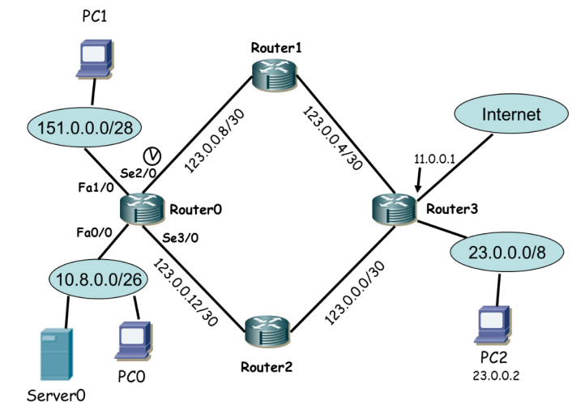

**1)** IP addresses assignment strategy is based on the following guidelines:

**a.** Router0 interfaces must use the last available address of the address block (in the case of clock, use 64000 value).

**b.** IP addresses for network 151.0.0.0/28 must be assigned statically (IP address 151.0.0.10 must not be used).

**c.** IP addresses for network 10.8.0.0/26 must be assigned dynamically, excluding from the block of dynamic IP addresses the first 8 available addresses. Server0 must have IP address 10.8.0.23

**2)** Routing must be configured considering that:

**a.** OSPF is already enabled on routers Router1, Router2 and Router3;

**b.** the number of control messages should be minimized;

**c.** the path to network 23.0.0.0/8 must be the one crossing Router2, while all other paths must be the shortest ones.

**d.** The path to reach the Internet must be the one crossing Router1.

**3)** NAT must allow hosts of private networks to share the IP address of interface Se2/0 of Router0; as an exception, Server0 has to use public IP 151.0.0.10.

**Answers:**

**1):**

* For **netmask** like /26 we do like this 32 - 26 = 6 => 26 = 64 => 255 + 1 - 64 = 192

obtain like this /26 = 255.255.255.192, for the **wildcard** we do 0.0.0.63, because we do 255 - 192 = 63.

To calculate the last available ip address must remember that the first ip of a block is reserved to LAN, the last is reserved to Broadcast.

For each interface, like Se2/0 we must do:

Router(config)# **interface Se2/0**

Router(config-if)# **ip address <A.B.C.D.> <netmask>**

Router(config-if)# **clock rate 64000**

Router(config-if)# **no shutdown**

* For assign dynamically the ip address:

Router(config)# **ip dhcp pool exam**

Router(config-dhcp)# **network A.B.C.D. NETMASK**

Router(config-router)# **default-router A.B.C.D**

Router(config)# **ip dhcp excluded-address <IP_OF_SERVER>**

Router(config)# **ip dhcp excluded-address 10.0.8.0.1 10.0.8.0.8**

**2):**

* For **router0** we have 3 public networks and 10.8.0.0 that is private, ospf must be enabled only on the first 3:

Router(config)# **router ospf 1**

Router(config-router)# **network 151.0.0.0 0.0.0.15 area 0**

Router(config-router)# **network 123.0.0.8 0.0.0.3 area 0**

Router(config-router)# **network 123.0.0.12 0.0.0.3 area 0**

The number of messages must be minimized implies that where possible must use passive-interfaces:

Router(config-router)# **passive-interface Fa1/0**

* For the third point we must change cost of a path for example we add 1 to the upper one, default for a serial is 64:

Router(config)# **interface Se2/0**

Router(config-if)# **ip ospf cost 65**

* In general we must use the default route for go to internet (S*), if router3 is accessible we add static route and redistribute to another router with ospf, here we add this in router0:

Router0(config)# **ip route 0.0.0.0 0.0.0.0 123.0.0.9**

**3):**

* For the private network use inside for other outside:

Router(config)# **interface Fa0/0**

Router(config-if)# **ip nat inside**

Router(config)# **interface Se2/0 (SAME FOR Se3/0 and Fa1/0)**

Router(config-if)# **ip nat outside**

* We do overload on Se2/ and add a static translation for the server:

Router(config)# **access-list 1 permit 10.8.0.0 0.0.0.63**

Router(config)# **ip nat inside source list 1 interface Se2/0 overload**

Router(config)# **ip nat inside source static 10.8.0.23 151.0.0.10**

# EXAM 2

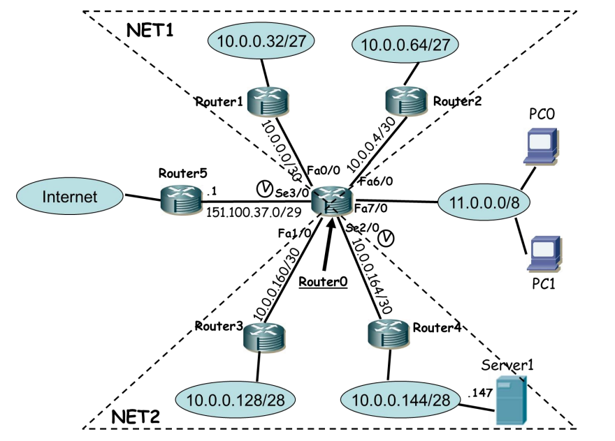

The devices to be configured are Router0, PC0 and PC1.

**1)** The IP addresses should be assigned considering the following rules:

**a.** The interfaces of Router0 must have the last IP address of the blocks (in the case of a clock

rate, value 64000 should be used).

**b.** In the network 11.0.0.0/8, addresses must be assigned dynamically; the first useful 10

addresses must be excluded by the dynamic assignment procedure.

**2)**  OSPF protocol must be enabled on the NET1 network portion, while RIP protocol must be enabled on the NET2 network portion.

**3)** All networks must have an Internet access configured.

**4)** NAT must be implemented so that all hosts will use the public IP address of the Se3/0 interface of Router0; the only exception is Server1 that must use an available IP address in the block of network between Router0 and Router5.

**Answers:**

1. Same as before.
2. For ospf the commands are the same, for rip we must use **version 2** and also **no auto summarize**
3. default route **0.0.0.0 0.0.0.0 151.100.37.1** must be added statically and must be use **default-information originate** in ospf and rip
4. We have that Se3/0, Fa7/0 are outside while Fa0/0 Fa1/0 Fa6/0 Se2/0 are inside

must use **access-list 1 permit 10.0.0.0 0.0.0.255** , we use /24 because it contains all private networks of the router /27 and /28, use one command instead of doing more lines. After we do:

Router(config)# **ip nat inside source list 1 interface Se3/0 overload**

Router(config)# **ip nat inside source static 10.0.0.147 157.100.37.3**

# EXAM 3

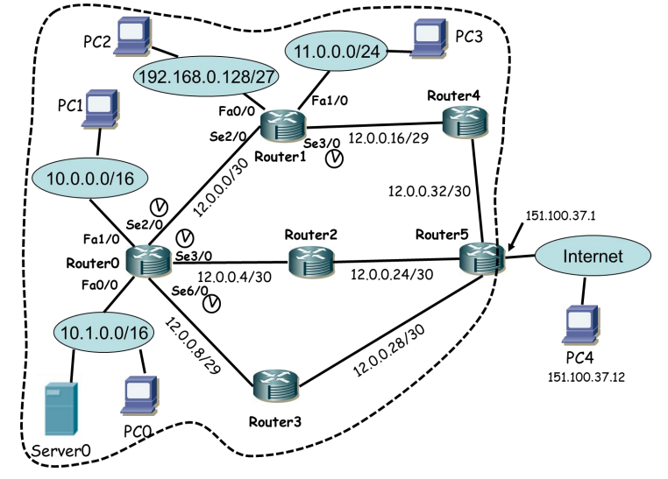

The student has to configure the following devices: Router0, Router1, PC0, PC1, PC2, PC3 and Server0. The dotted line represents the area managed by the same administrative entity (ISP). The following operations must be executed:

**1)** IP addresses assignment strategy is based on the following guidelines:

**a.** Router0 interfaces must use the last available address of the address block (in the case of clock,

use 64000 value).

**b.** Router1 interfaces must use the first available address of the address block (in the case of

clock, use 64000 value).

**c.** IP addresses for networks 10.0.0.0/16, 192.168.0.128/27 and 11.0.0.0/24 must be assigned

statically.

**d.** IP addresses for network 10.1.0.0/16 must be assigned dynamically, excluding from the block of

dynamic IP addresses the first 15 available addresses. Server0 must have IP address 10.1.0.18

**2)** Routing must be configured considering that:

**a.** OSPF is already enabled on Router2, Router3, Router4 and Router5, and links costs are 1 for

FastEthernet interfaces and 64 for Serial interfaces;

**b.** the number of control messages should be minimized;

**c.** for Router0, OSPF must not use Router3 as next hop while Internet must be reached using

Router3 as next hop;

**d.** for Router1 Internet must be reached using Router4 as the next hop.

**3)** NAT must be configured where needed using a feasible solution (your choice).

**Answers:**

**1)** Same of before.

**2)** in ospf we must not add private networks 10.1.0.0, 10.0.0.0 and 192.168.0.128, the only passive-interface is Fa1/0 of Router1, for point **c.** we increase Se6/0 of Router0 to AD (cost) 129. In router1 must add 0.0.0.0 0.0.0.0 12.0.0.18 as route for the internet.

**3)** We have that Se2/0, Se3/0 and Se6/0 are outside while Fa0/0 Fa1/0 are inside must use **access-list 1 permit 10.0.0.0 0.1.255.255** , we use /15 because it contains all private networks 10.0.0.0 and 10.1.0.0, use one command instead of doing more lines. After we do:

Router(config)# **ip nat inside source list 1 interface Se6/0 overload**

Router(config)# **ip nat inside source static 10.1.0.18 12.0.0.10**

# LAST MIDTERM

